**REVIEW UNIT 12**

1. **Complete the text. Use the words from the box**

|  |
| --- |
| Birthday card candles remote - control car sing karaoke have a bowling party have fireworks  have a costume party batteries |

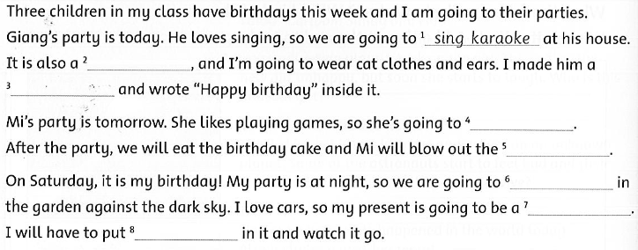

1. 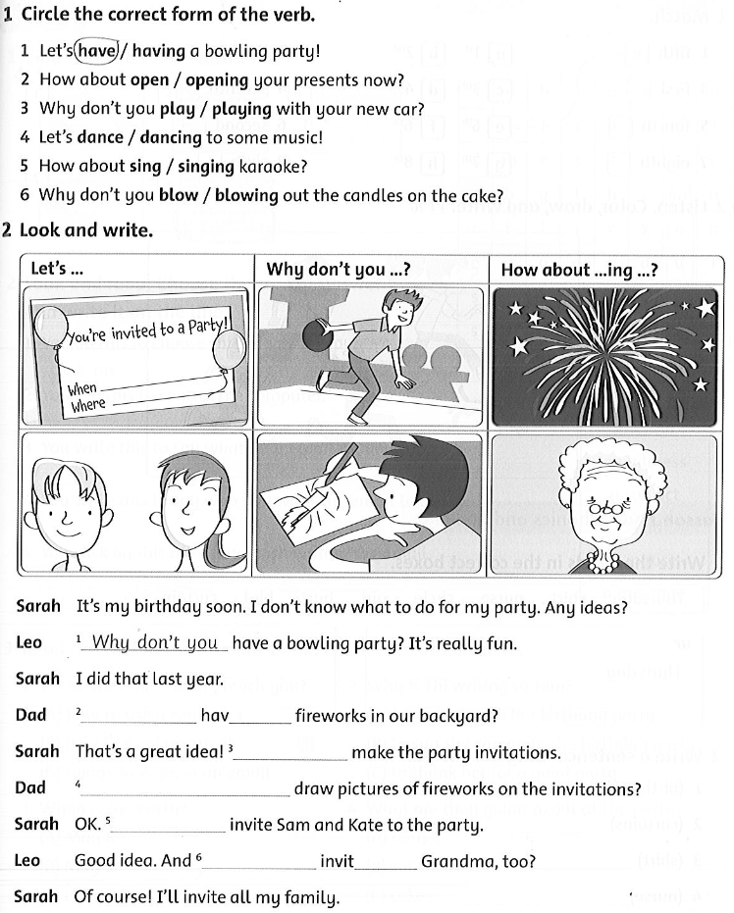**Circle the correct forrm of the word from the box opening play dance singing blow**
2. **Look and write**





1. **You are having a party. Choose the kind of party from the words below. Then answer the questions**

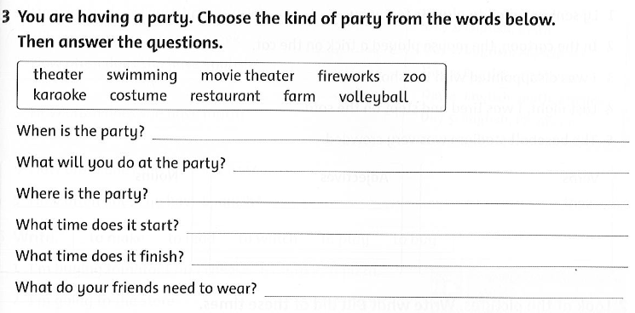

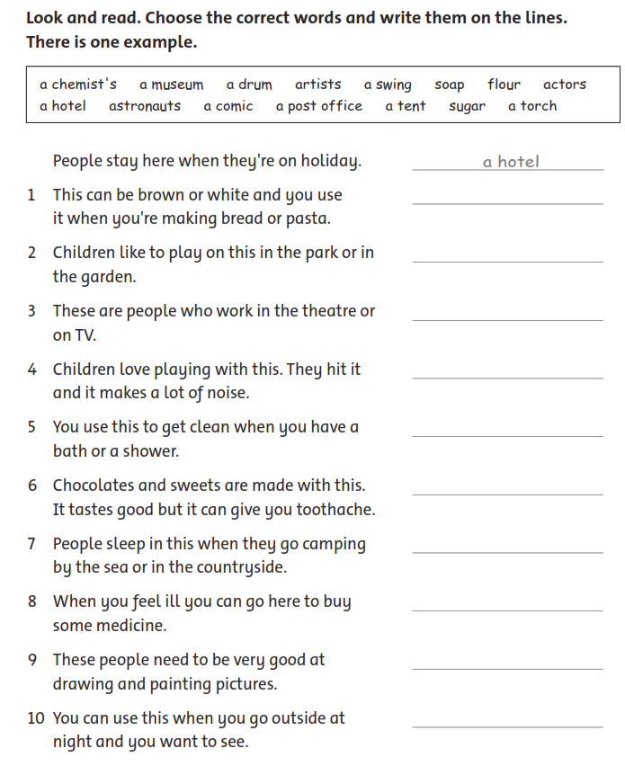

**Answer key**

1. **Complete the text. Use the words from the box**

2**,** have a costume party

3, Birthday card

4, have a bowling party

5, candles

6, have fireworks

7, remote - control car

8, batteries

1. **Circle the correct forrm of the word from the box**

2**,** opening

3, play

4, dance

5, singing

6, blow

1. **Look and write**

2**,** How about having …?

3, let’s make

4, why don’t you draw …?

5, let’s invite

6, How about inviting …?

1. **You are having a party. Choose the kind of party from the words below. Then answer the questions**

1, 5he party is on Saturday.

2, we will sing karaoke .

3, the party is in the restaurant.

4, it starts at 6: 30 p.m .

5, it finishes at about 9: 00 p.m .

6. They need to wear jeans or dress.

1. **Look and read, choose the correct words and write them on the lines. There is one example**

1, flour.

2, a swing

3, actors.

4, a drum.

5, soap.

6, sugar.

7. a tent.,,

8, a chemist’s.

9, artists.

10, torch.